1. Ble Connect

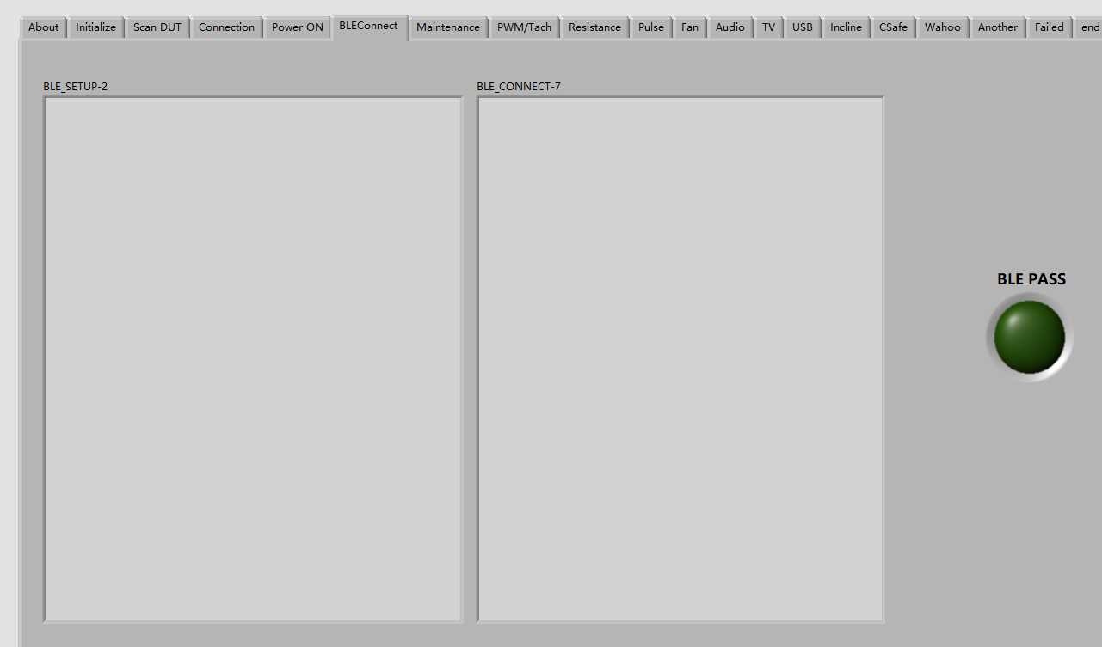

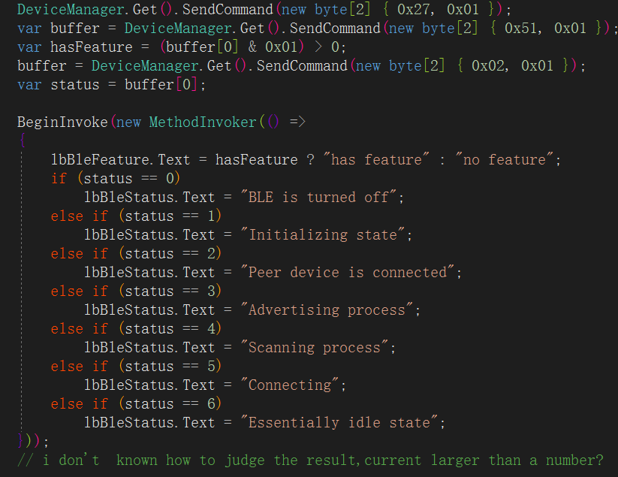

Question: What commands do I need to send to trigger a Bluetooth connection?

1. Resistance test

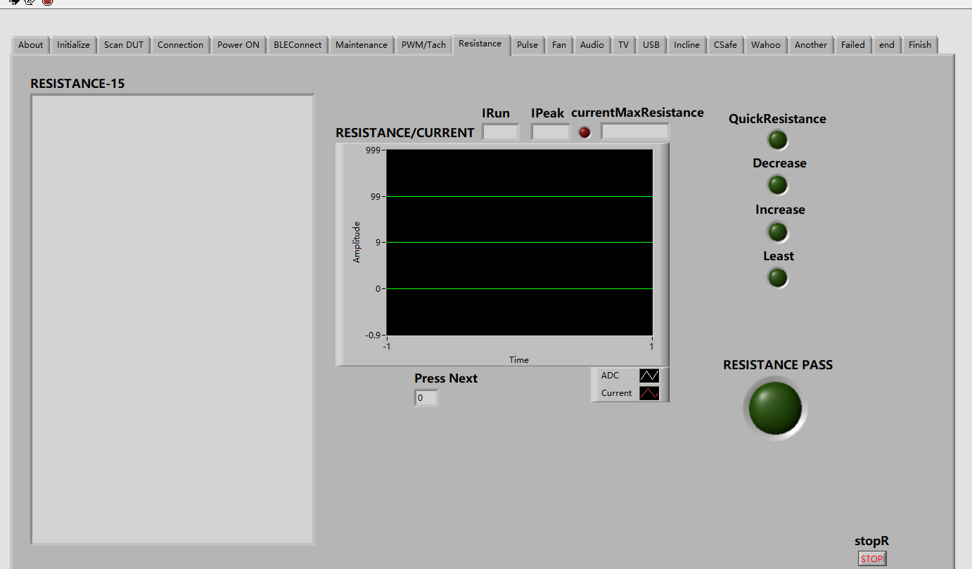

Question: how to test quick resistance? By comparing the resistance voltage?

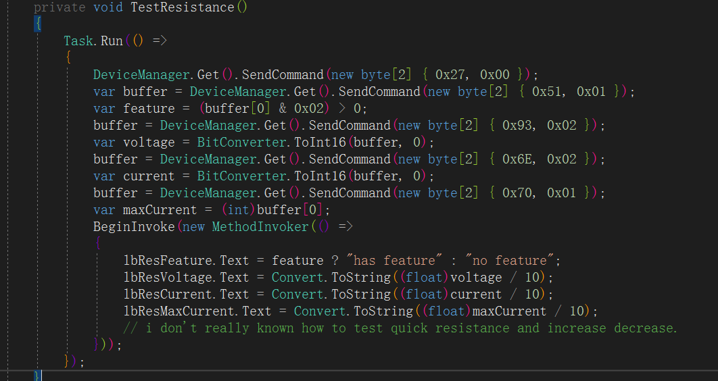

1. Pulse test

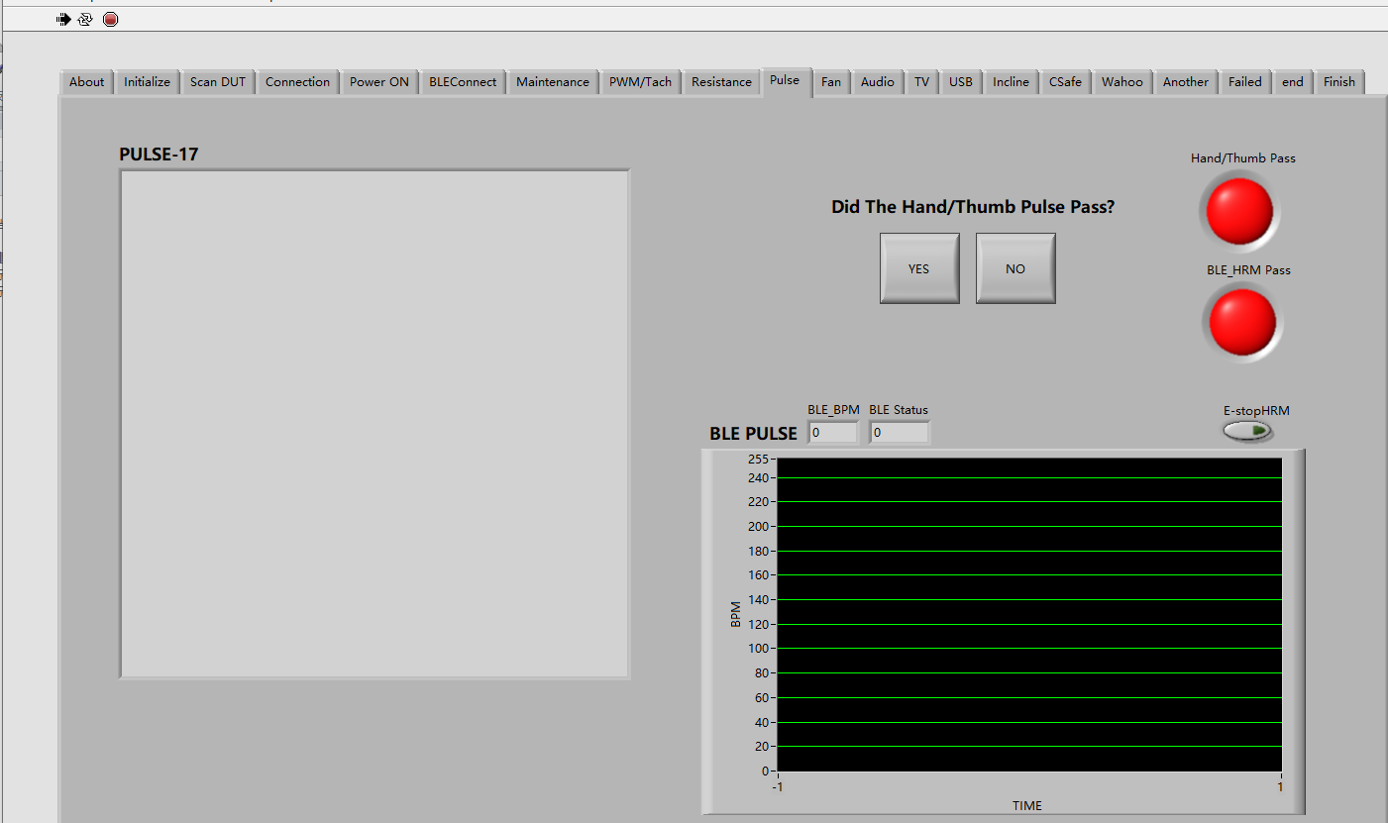

Question: How to judge the result?

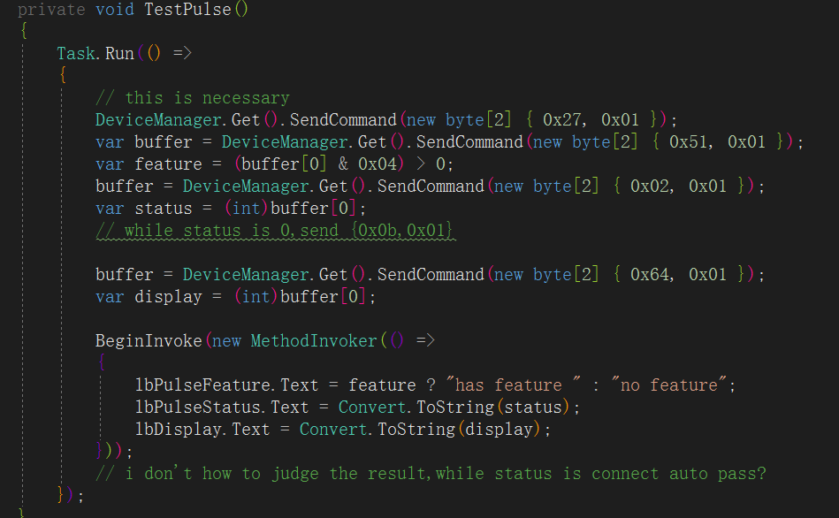

1. Fan Test

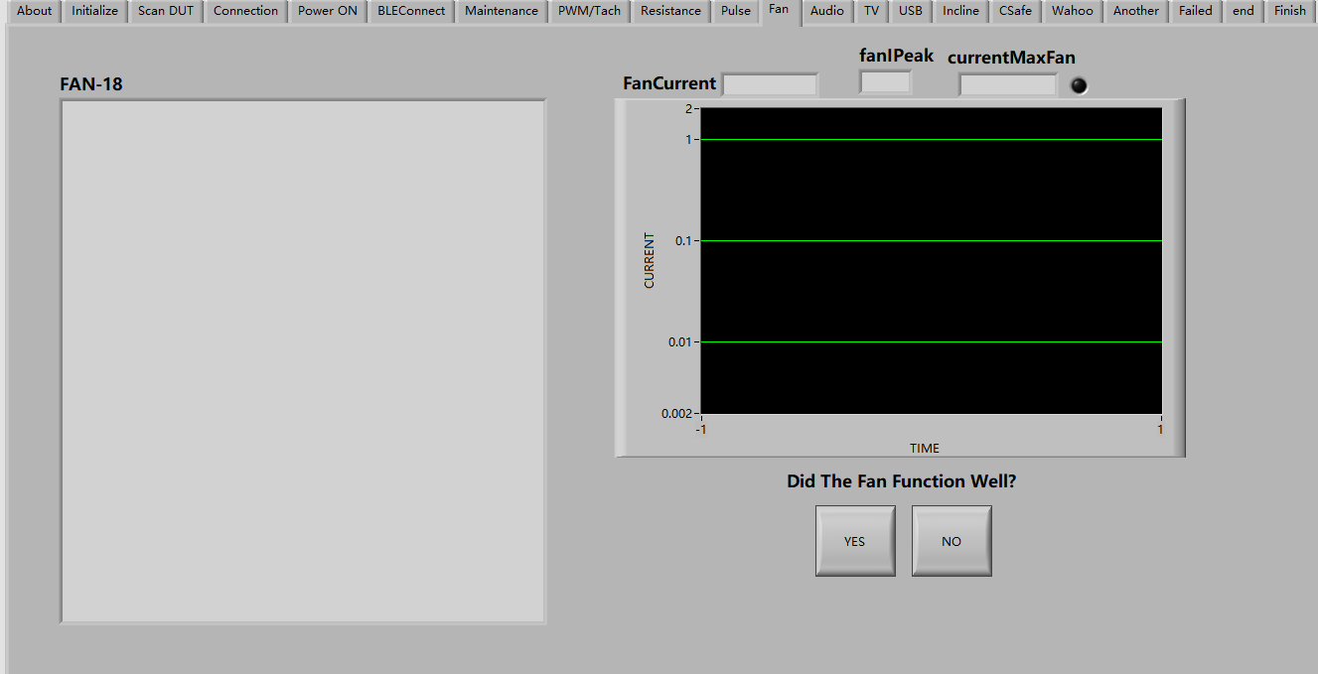

Question: when read the current, if the current greater a number, is it PASS?

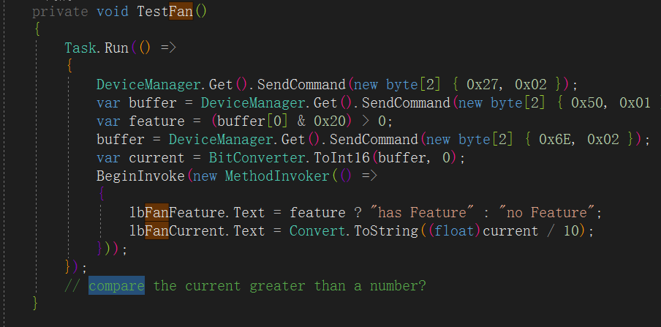

1. Audio Test

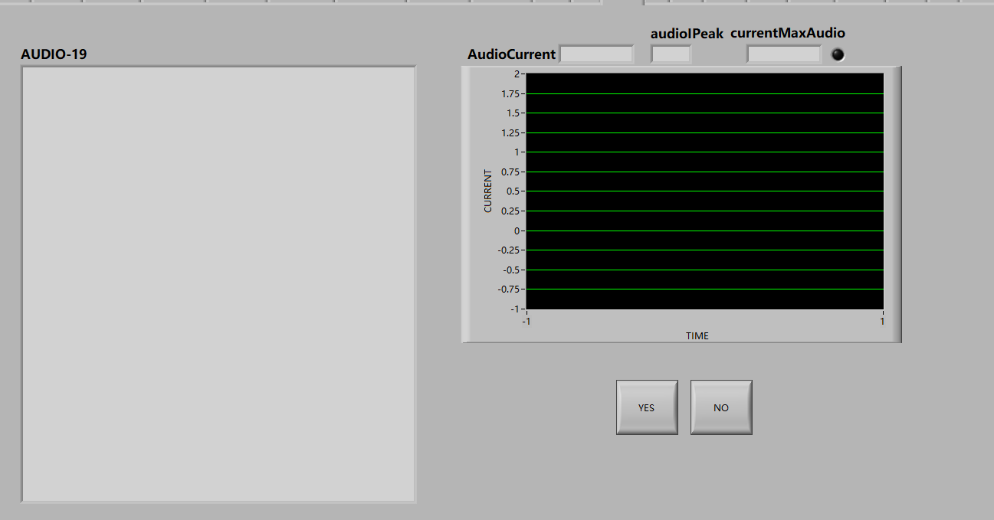

Question: when read the current, if the current greater a number, is it PASS?

1. incline test

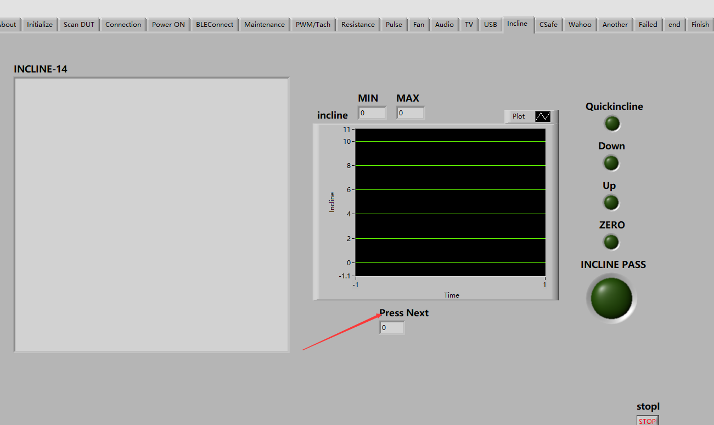

Question: which command can read “press next” indicator?

1. other test

TV/CSafe/wahoo/USB are judged by operator, why display the current?

Below are the questions when we test with your labview:

1. It is not necessary to confirm the connection.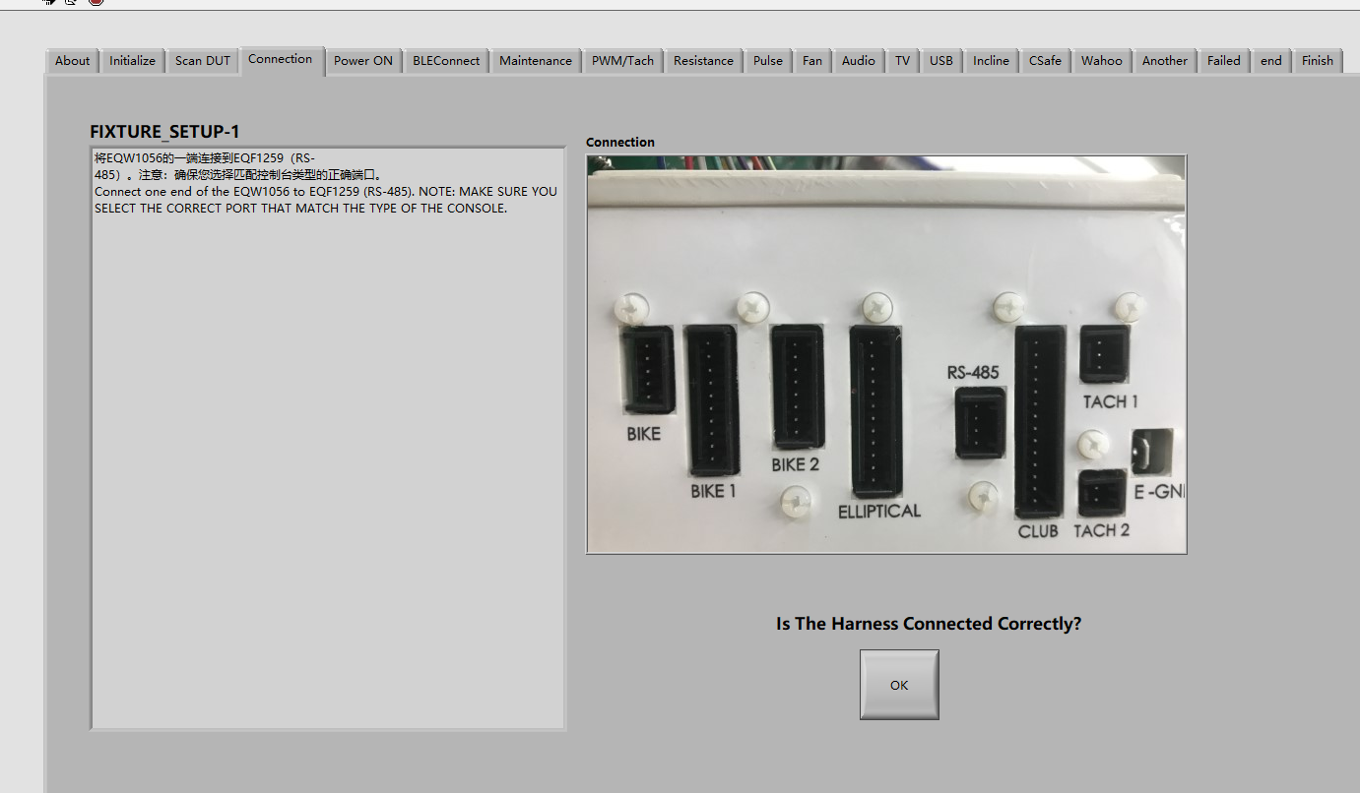Issue: the power supply is provided by the communication cable. otherwise, the screen will not light up.

suggestion: remove this item.

2、It is not necessary to confirm cosmetic inspection.

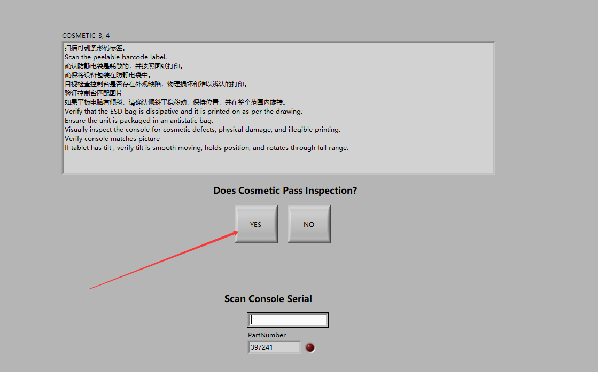

issue: cosmetic inspection is better to be put in the last testing step (before packing)

suggestion: put this item in the last step before packing.

3、It is not necessary to confirm power on

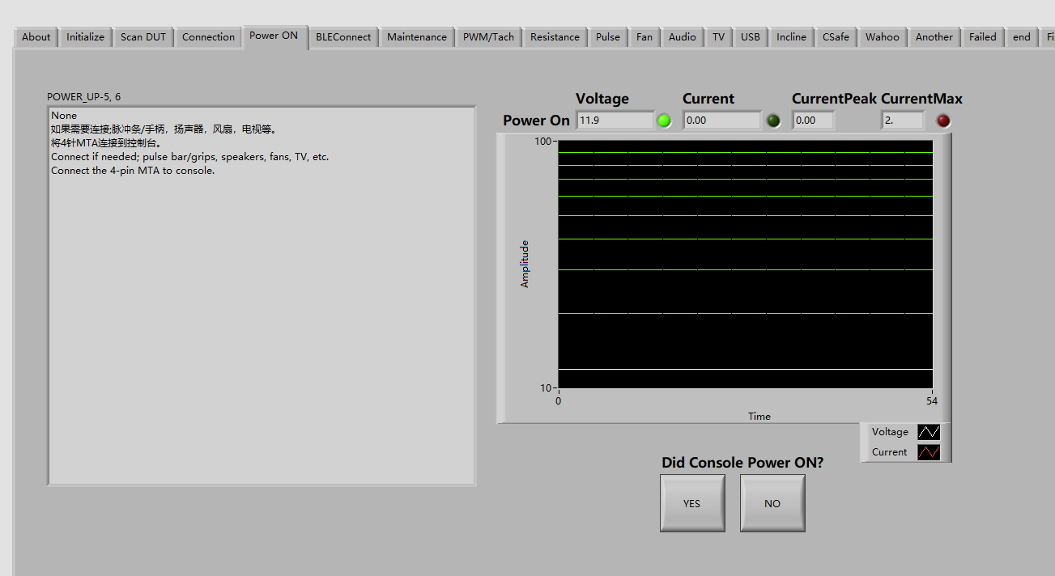

issue: If there is no power, the screen will not light up.

suggestion: remove this item

4、enter the version number is not very reasonable.

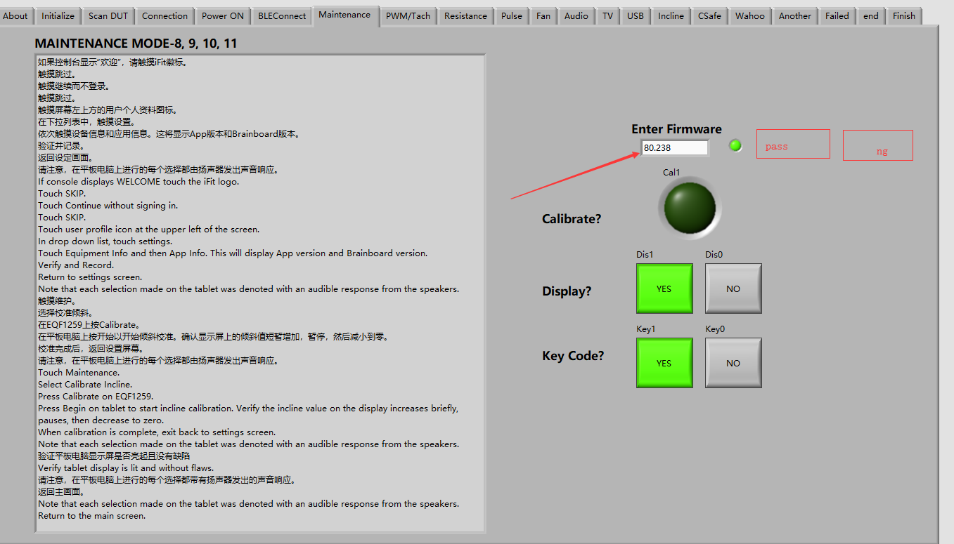

issue: when the wrong version number was found, the operator will check it out and product needed to be reworked.

suggestion: indicator the right firmware number, put the pass button and NG button, while press NG, the test tool will go to failed page.

5、the quick resistance test is not very reasonable.

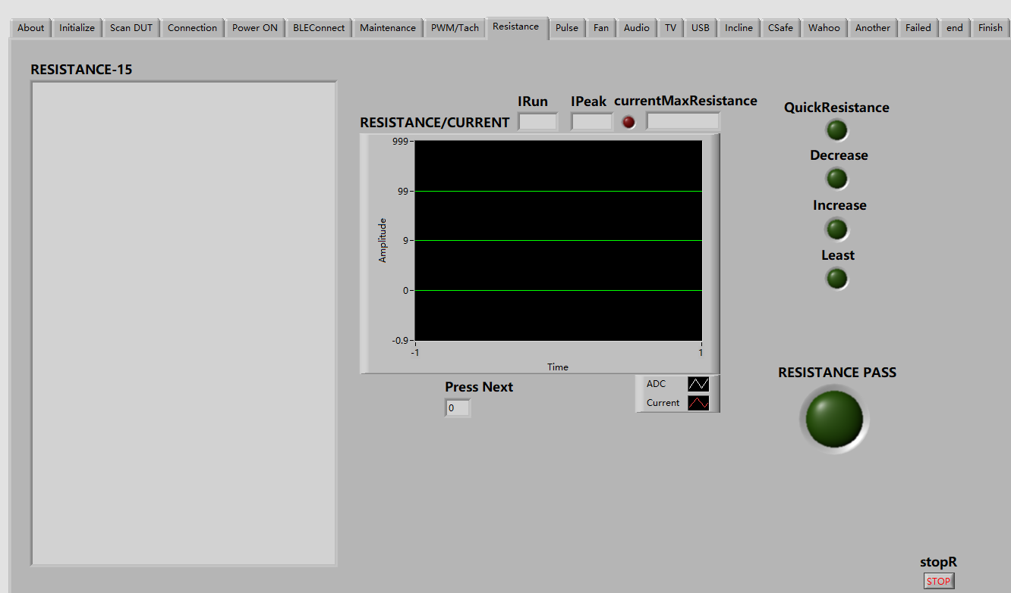

issue: it is no easy to pass the quick resistance automatically. and sometimes operator need retest some of the quick resistance button, but the tool judge PASS automatically. Some quick resistance button is not very well.

suggestion: It will be more efficient to check the screen display resistance number, judge by operator.

6、Fan test is not very reasonable.

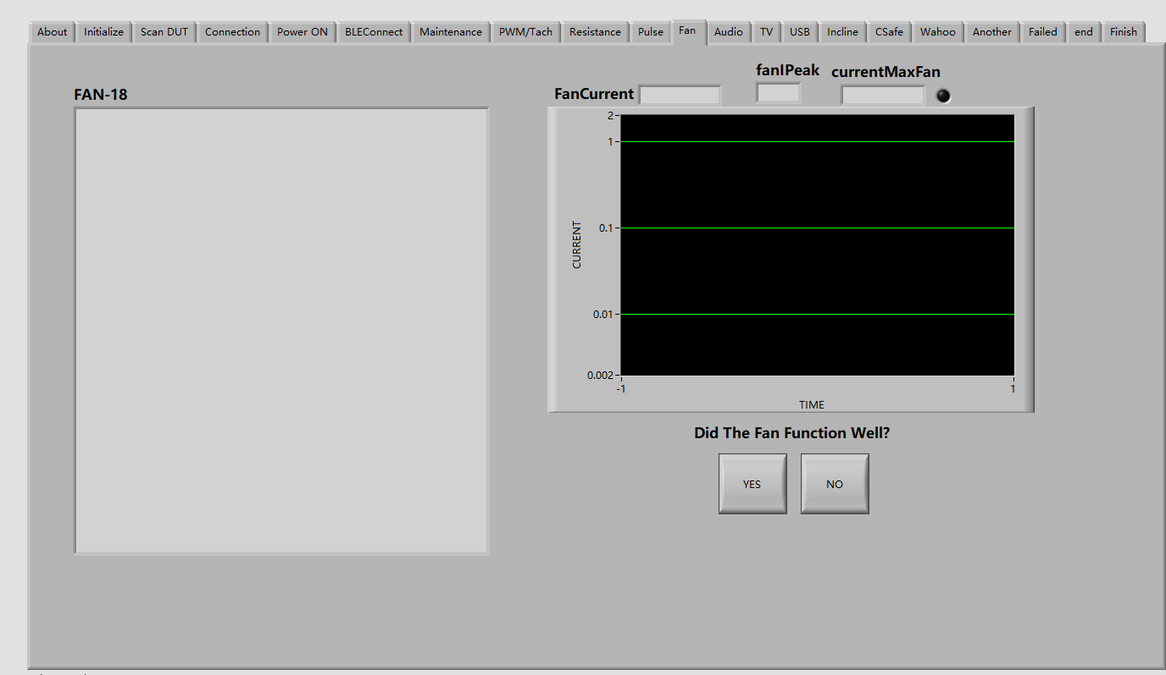

issue: Fan noise cannot be checked out automatically.

suggestion: judge by operator

7、Audio test is not very reasonable.

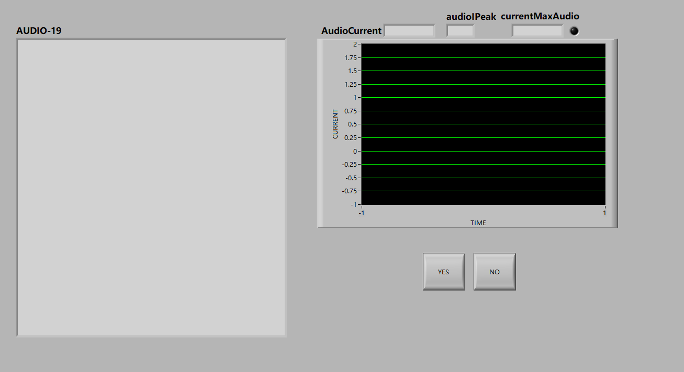

issue: it is not easy pass automatically. And left or right wrong channel can not be checked out automatically. Noise can not be checked out automatically.

suggestion: judge by operator

8、incline test is not very reasonable.

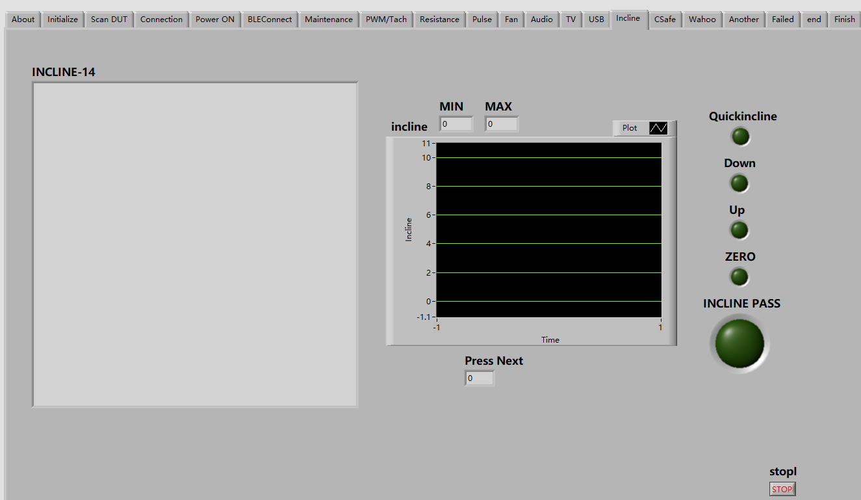

issue: sometime operator need retest some of the quick incline, but tool judge PASS automatically. some incline button is not very well.

suggestion: judge by operator